Module 5 Discussion

Using the 100 Things Every Designer Should Know About People reading assignment, select two (2) of the "things" you read about, include the number and title of the "thing" (i.e., #36 Time is Relative) , and then do two embellishments, one embellishment and one visual example, or two visual examples.
- Embellish: Tell us something that the reading did not tell us on that specific "thing" or embellish on what was presented. Be sure you are adding meaningful content to the conversation and not just making noise. Your addition can be a link to an article, or you can write out your embellishment.
- Visual Example: Provide us with a graphic example that is relevant to web design. This can be something you create or something you find. Again, be sure to add meaningful content to the conversation.

Topic #40: Attention is Selective
Embellishment:
Selective attention shows up for me any time I am focused on a specific task. When I am working on a programming assignment or focusing on a problem, I can completely miss what is happening around me. People might be talking nearby, notifications might appear on my screen, or music might be playing, but if it does not relate to what I am focused on, my brain filters it out. This is not a failure of attention. It is how the brain avoids being overwhelmed by too much information at once.
The same thing happens in web design. When users visit a website, they do not carefully read everything on the page. Instead, they scan quickly and focus only on what helps them accomplish their goal. Anything that does not seem useful to that goal is ignored, even if it is visible on the screen. Designers sometimes assume that users will notice all the content they place on a page, but selective attention means that this is rarely the case.
Because attention is selective, web design has to guide users toward what matters most. Important information needs to be easy to recognize and clearly connected to what the user is trying to do. If a page does not make that clear, users may overlook key content without realizing it was there at all.
Visual Example:
A good visual example of selective attention is the Google search page. The homepage is very simple, with the search bar centered on the page. This works because it matches what users are there to do. There are no extra elements competing for attention.
On the search results page, information is organized to support scanning. Page titles stand out more than the surrounding text, and links are easy to identify. Users quickly move down the page, paying attention only to results that match what they are looking for. Google’s design works well because it accepts that users are selective with their attention and structures the page around that behavior.
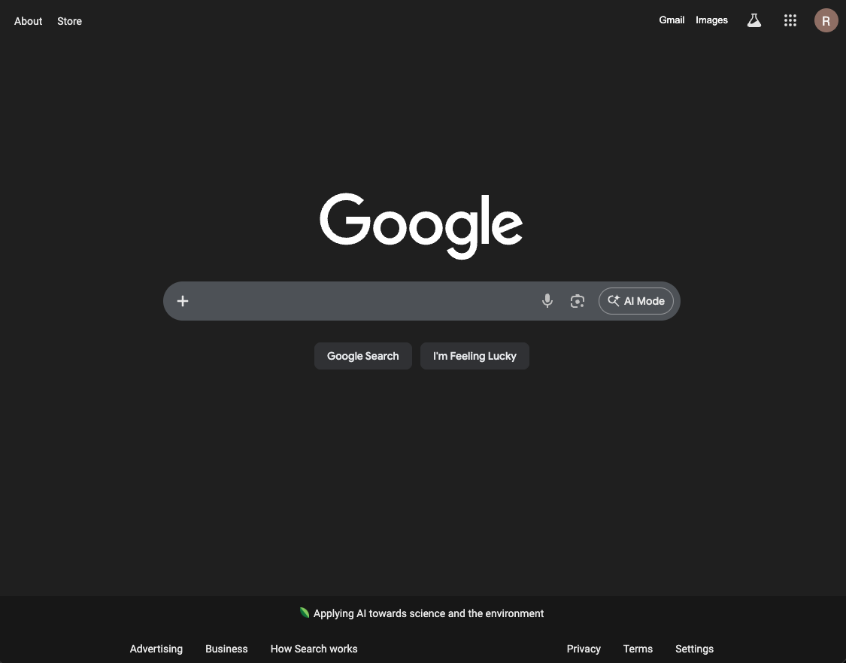

Topic #41: People Habituate to Information
Embellishment:
This happens to me at work all the time. I work in a place with a walkie-talkie-style radio to communicate with my coworkers. This radio is busy most of the day, so a lot of information is coming across it. A lot of it isn't relevant to my day or what I do, so I zone it out and don’t hear over ½ of what is said. But when someone calls my name, or my job title, it breaks that “zone out,” and I suddenly hear what is being said. The caveat here is that I start hearing a little bit before when the title or name is said, almost as if I buffer a little bit of what was said and recall it when I snap out.
This happens in web designs as well. Users will quickly learn to ignore low-relevance items, such as banner ads, menu bars, or dense blocks of text. So, to make something important stand out, you need to make it distinct, like a call to action.
Visual Example:
For a visual example, I give you the Amazon website. Their page gives LOTS of information about a product, but the “Add to cart” and “Buy Now” buttons stand out with bright yellow and orange. They stand out and make you notice that they are there, breaking through the “noise” of the sidebar with other options like “add to list” or the type of book you select.
